**Table of Contents**

How To Use This Guide 2

Accessing UKG 2

Preferred Language Settings 3

Process Hire Wizard 7

Converting Temp/Hourly Employee 15

Changing Employee Job/Pay Rate 26

Supervisor Changes/Mass Edits 30

WFM Overview 35

Employee Status Changes 51

Business Intelligence (BI) Reporting 57

Department Contacts 64

# How To Use This Guide

#### Welcome! The following guide is intended to be your source document for all your Employee Self Service needs.

**Accessing UKG**

Employees can manage their data via the Web or Mobile App. Once you receive your Username and Temporary Password you will want to login into the system and change your password. You can do this via the web or app.

**From the Web:**

* UKG Web Address: <https://nw14.ultipro.com>
* Username/Login: Email address (Example [jsmith@yahoo.com](mailto:jsmith@yahoo.com))
* Temporary Password: Complete DOB (mm/dd/yyyy)
* After your initial login, the system will prompt you to change your password and setup your challenge questions.

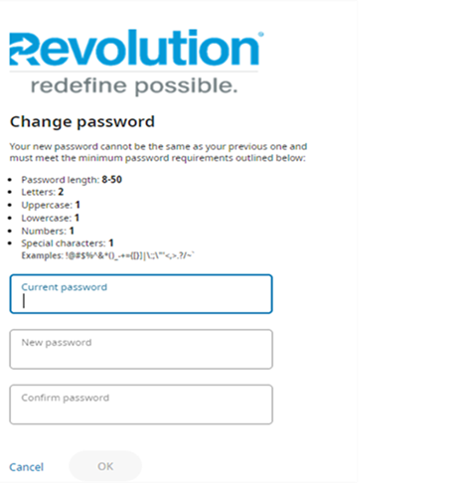 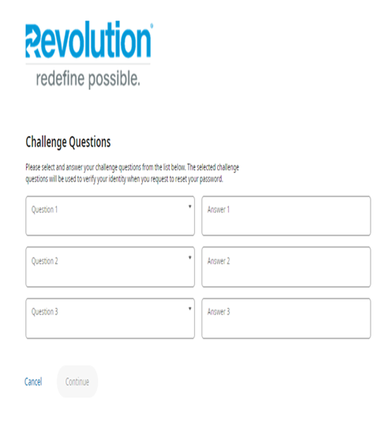

To access the Mobile App, download it from either the Apple or Google Play Store. Once downloaded, open the app and you will enter our company access code **“Revolution1”,** thelogin screen will appear, and you enter your Username and Password.

**Preferred Language Settings**

Whether your preferred language is English or Spanish you can set up yourself how you wish to view your payroll data!

From the home page, click on the “User Account Icon” in the upper right corner

Select Preferences

Select Edit>Language>Chose a language from the drop-down menu then select save

You can make these same changes in the UKG App >Chose Menu> Settings

**Electronic Forms Election**

Whether your preferred language is English or Spanish you can set up yourself how you wish to view your payroll data!